# **Name: Abdurrahman Qureshi**

# **Roll No: 210451**

Practical No: 9

**1)** **Develop a program to demonstrate the use of JProgressBar**

**CODE:**

import javax.swing.*;

import java.awt.*;

public class Main {

JProgressBar myProgressBar;

public Main() {

JFrame frame = new JFrame("My Progress Bar"); frame.setBackground(Color.DARK_GRAY);

frame.setForeground(Color.WHITE);

Panel P = new Panel();

myProgressBar = new JProgressBar(1, 500);

myProgressBar.setSize(200,200);

P.setLayout(new FlowLayout(1));

P.add(new JLabel("Progress Bar"));

P.add(myProgressBar);

P.setSize(100,100);

frame.add(P);

frame.setSize(400, 300);

frame.setDefaultCloseOperation(JFrame.EXIT_ON_CLOSE);

frame.setVisible(true);

loadProgressBar();}

public void loadProgressBar() {

for (int i = 1; i <= 500; i++) {

myProgressBar.setValue(i);

try {

Thread.sleep(10);

} catch (Exception ignored{}}}

public static void main(String[] args) {

new Main();}}

**OUTPUT:**

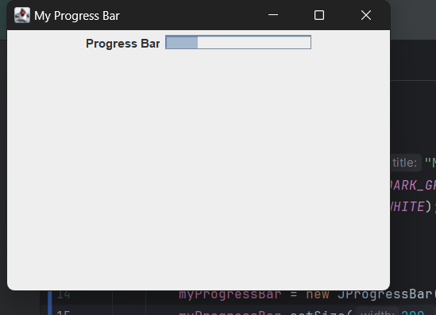

**2)** **Write a Program using JProgressBar to show the progress of Progressbar when user clicks on JButton**

**CODE:**

import javax.swing.*;

import java.awt.*;

import java.awt.event.ActionEvent;

import java.awt.event.ActionListener;

public class Main {

JProgressBar myProgressBar;

public Main() {

JFrame frame = new JFrame("My Progress Bar");

frame.setBackground(Color.DARK_GRAY); frame.setForeground(Color.WHITE);

Panel P = new Panel();

myProgressBar = new JProgressBar(1, 50);

myProgressBar.setSize(200,200);

P.setLayout(new FlowLayout(1));

JButton startButton = new JButton("Increase Progress");

startButton.addActionListener(e -> loadProgressBar());

P.add(new JLabel("Progress Bar"));

P.add(myProgressBar);

P.add(startButton);

P.setSize(100,100);

frame.add(P);

frame.setSize(400, 300);

frame.setDefaultCloseOperation(JFrame.EXIT_ON_CLOSE);

frame.setVisible(true);}

public void loadProgressBar() { myProgressBar.setValue(myProgressBar.getValue() + 1);

try {

Thread.sleep(10);

} catch (Exception ignored{}}

public static void main(String[] args) {

new Main();}}

**OUTPUT:**

**3)Generate the following output**

**CODE:**

import javax.swing.*;

import java.awt.*;

public class Main {

JProgressBar myProgressBar;

JLabel JL;

public Main() {

JFrame frame = new JFrame("My Progress Bar"); frame.setBackground(Color.DARK_GRAY);

frame.setForeground(Color.WHITE);

Panel P = new Panel();

JL = new JLabel("0%");

myProgressBar = new JProgressBar(1, 500);

myProgressBar.setSize(200,200);

P.setLayout(new FlowLayout(1));

P.add(new JLabel("Progress Bar"));

P.add(myProgressBar);

P.add(JL);

P.setSize(100,100);

frame.add(P);

frame.setSize(400, 300); frame.setDefaultCloseOperation(JFrame.EXIT_ON_CLOSE);

frame.setVisible(true);

loadProgressBar();}

public void loadProgressBar() {

for (int i = 1; i <= 500; i+=5{

myProgressBar.setValue(i);

JL.setText(i + "%");

try {

Thread.sleep(100);

} catch (Exception ignored) {}}}

public static void main(String[] args) {

new Main();}}

**OUTPUT:**

